**GROUP 8:**

**BAGADIONG**

**FAJARDO**

**MACHINE PROBLEM #3 (MATLAB SOLUTION)**

**Test:**

Input values: [1 2; 3 4; 5 6; 7 8; 9 10]

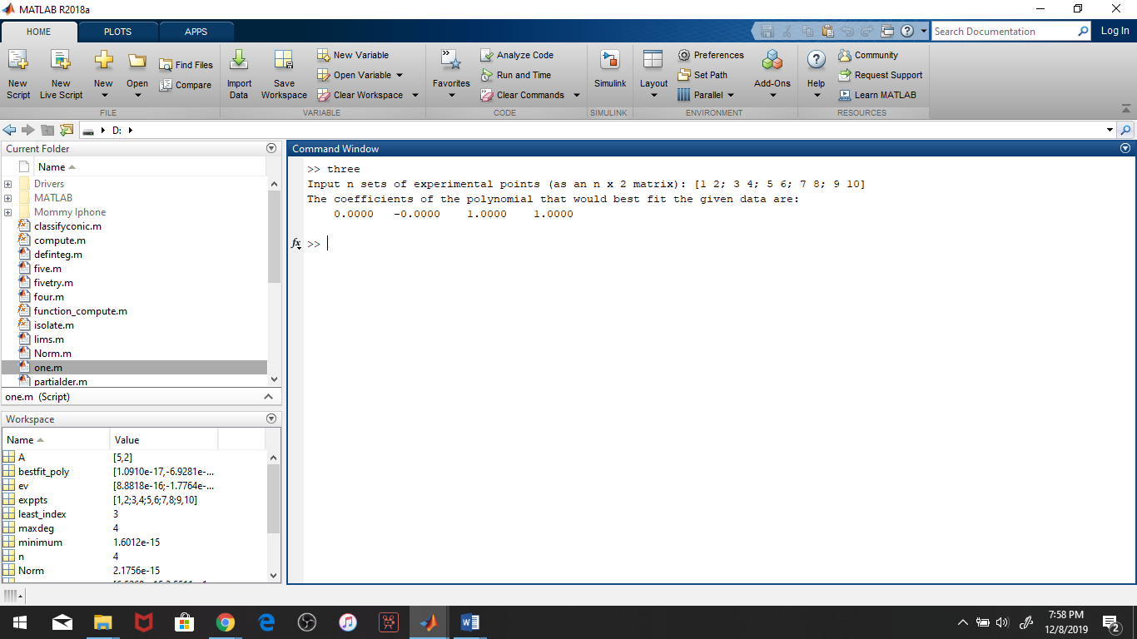

**Script file:**

